Process Definition Document (PDD)

*Process Name: <Employment Authorization Adjudication Process>*

Table of Contents

**Introduction** **1**

Purpose of the Document 1

Objectives 1

Process Key Contact 1

Minimum Prerequisites for Automation 1

**As-Is Process Description** **2**

Process Overview 2

Applications used in the Process 3

As-Is Process Map 3

**To-Be Process Description** **3**

Detailed Process Map 3

Robot Type 4

Business Exceptions Handling 4

Known Exceptions 4

Unknown Exceptions 4

System Exceptions Handling 4

**Other Observations** **5**

**Additional sources of process documentation** **5**



# Introduction

## Purpose of the Document

The Process Definition Document outlines the business process chosen for automation using UiPath Robotic Process Automation (RPA) technology.

The document describes the sequence of steps performed as part of the business process, the conditions and rules of the process prior to automation and how they are envisioned to work after automating it, partly or entirely. This specifications document serves as a base for developers, providing them with the details required for applying robotic process automation to the selected business process.

## Objectives

The business objectives and benefits expected by the Business Process Owner after automation of the selected business process are:

* Include at least one here
* Up to as many as you want

## Process Key Contact

The specifications document includes concise and complete requirements of the business process and it is built based on the inputs provided by the process Subject Matter Expert (SME)/ Process Owner.

The Process Owner is expected to review it and provide signoff for accuracy and completion of the steps, context, impact and a set of process exceptions. The details are to be included in the table below.

|  |  |  |  |
| --- | --- | --- | --- |
| Role | Name | Contact Details  (email & phone number) | Notes |
| Process Owner | USCIS Department | +1 (800) 375-5283 | United States Immigration Department |
| Business Analyst | Purnima Singh | 224-830-5525 |  |

## Minimum Prerequisites for Automation

|  |  |
| --- | --- |
| Met (Y/N) | Prerequisites |
| Y | A filled in and completed Process Definition Document |
| Y | Closure of any open process questions |
| Y | Environment set up |
| Y | Test Data to support development and testing |
| Y | User access and creation of user accounts (licenses, permissions, restriction to create accounts for robots) |

# As-Is Process Description

## Process Overview

General information about the process selected for RPA prior to automation.

|  |  |  |
| --- | --- | --- |
| # | Item | Description |
| 1 | Process Full Name | Employment Authorization Adjudication Process |
| 2 | Process Area | Dependent EAD(Employment Authorization Document) |
| 3 | Department | USCIS |
| 4 | Process Short Description  (Operation, activity, outcome) | Employment Authorization Adjudication Process for USCIS department |
| 5 | Role(s) required for performing the process | USCIS Officer |
| 6 | Process schedule and frequency | Up to the business owner |
| 7 | # of items processed /reference period | NA |
| 8 | Process execution time | 7-9 Months and when USCIS officer picked the case it takes 15 mins to process single standalone H4EAD case. |
| 9 | Peak period(s) | NA |
| 10 | Transaction Volume During Peak period | NA |
| 11 | Total # of FTEs supporting this activity | NA |
| 12 | Expected increase of volume in the next reference period | NA |
| 13 | Level of exception rate | NA |
| 14 | Input data | Documents sent by the applicants |
| 15 | Output data | Approval Or Rejection of EAD Email |

*Add more rows to the table to include relevant data for the automation process. No fields should be left empty. Use “n/a” for the items that don't apply to the selected business process.

## Applications used in the Process

The table includes a comprehensive list of all the applications that are used as part of the process to be automated to perform the given steps in the flow.

|  |  |  |  |  |  |
| --- | --- | --- | --- | --- | --- |
| # | Application Name & Version | System Language | Thin/Thick Client | Environment/ Access Method | Comments |
| 1 | Google Chrome |  | Thin Client |  | Browser should be installed on the system |
| 2 | MS Office suite |  |  |  | Licensed version |
| 3 | Adobe Acrobat reader |  |  |  |  |

*Add more rows to the table to include the complete list of applications.

## As-Is Process Map

**High Level As-Is Process Map:** This chapter depicts the As-Is business process at a High Level to enable developers to have a high-level understanding of the current process.

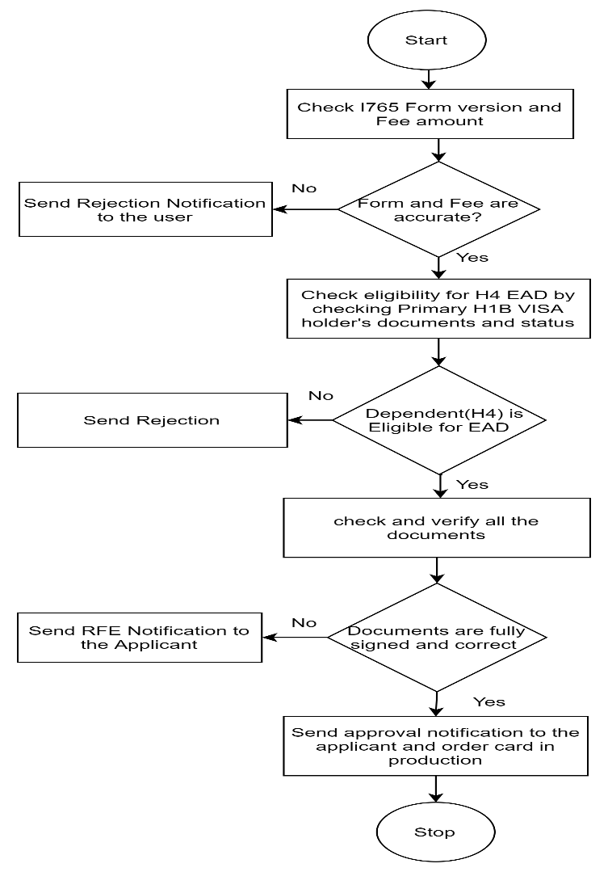

(IF ON GOOGLE DOCS GO TO INSERT DRAWING TO PUT YOUR DRAWING HERE)

**Detailed Process Map:** This chapter depicts the As-Is business process at a detailed view to enable process owners to document their process

|  |  |  |  |
| --- | --- | --- | --- |
| # | Step Action/Description | Screenshot | Remarks |
| 1 | Check I765 form version and fee amount |  | Form screen shot, Fee can be online or via check |
| 2 | Check Primary Visa holder (H1B )’s visa approval |  | There are other number of documents which are required to verify like Passport, Paystubs etc in real scenarios. |
| 3 | Check Primary Visa holder(H1B)’s I140 approval notice |  | This is a must have document |
| 4 | Check Applicant’s (H4 Visa holder)’s documents |  | There are other docs also need to be verified like Marriage certificate, Passport, State ID or DL etc |
| 5 | Check I94 record on online website |  | All US travelers record are maintained over this website |
| 6 | Send approval notification and card production ordered |  | Notification sends over the email. |

# To-Be Process Description

## Detailed Process Map

**High Level To-Be Process Map:** This chapter depicts the To-Be automation process at a High Level to enable developers/COE to have a high-level understanding of the to be developed process.

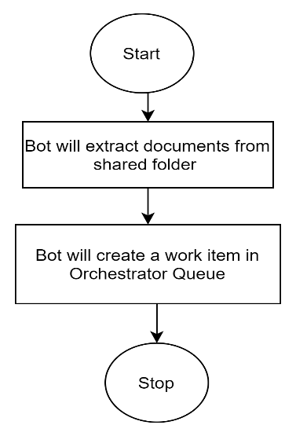

**Detailed Process Map:** This chapter depicts the To-Be automation process at a detailed view to enable developers/COE to see the workflows involved in the RPA solution

|  |  |  |  |  |  |
| --- | --- | --- | --- | --- | --- |
| **Workflow Name** | **Description** | **Pre-conditions** | **Post-actions** | **Arguments** | **Notes** |
| MainFlow | Employment Adjudication Dispatcher Process_MainFlow | User should have orchestrator account, bot should be installed on the system, | Work Item will be created in Orchestrator queue |  | Username, Password, H4EADFolderPath,ZipFolderPath,I765Form, these variables are used across the flow |
| ReadEmailsWorkflow | EmploymentAdjudicationDispatcher_ReadEmailsWorkflow | Bot should be able to connect with Orchestartor and fetch asset values | |  | | --- | | Zip File will be extracted at the folder Path | | Transaction Item will be added to the queue | |  | |  | |  | |  | |  | |  | |  | |  | |  | |  | |  | |  | |  | |  | | in_DownlOadZipPath, in_UserName, in_Password, inout_H4EADFoldrePath,in_I765Form |  |
| CreateQueueItemWorkflow | EmploymentAdjudicationDispatcher_CreateQueueItemWorkflow | Extracted files should be available in "H4EADDoc" folder path | Transaction Item will be added to the queue | in_EADFilePath, in_EADForm |  |

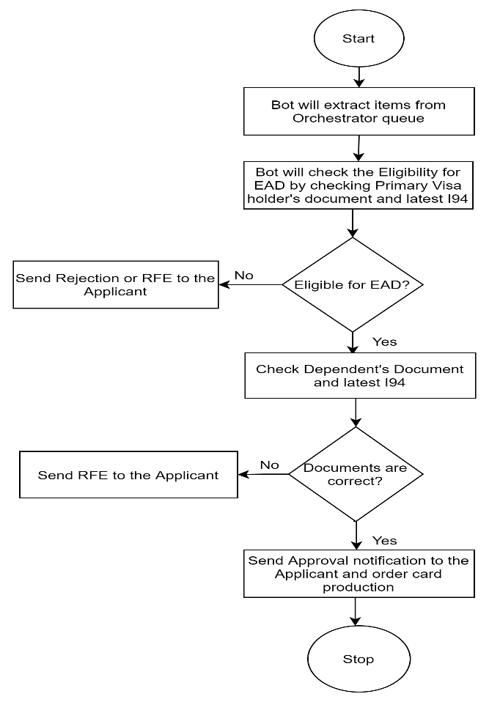

|  |  |  |  |  |  |
| --- | --- | --- | --- | --- | --- |
| **Workflow Name** | **Description** | **Pre-conditions** | **Post-actions** | **Arguments** | **Notes** |
| Main Workflow | EmploymentAdjudicationProcessProcessor_MainWorkflow | Items should be available on the queue | Status emails will be send to the applicant |  | Username, Password, H4EADFolderPath,ZipFolderPath,I765Form, TranscationItem, etc these variables are used across the flow |
| Processing of QueueItems Workflow | Processing of QueueItems Workflow | Items should be available in the queue | Status of items will be set | in_UserId,in_H4Noticepath in_Password,in_SSN,in_FolderPath,in_TransactionItem,in_Applicantmail,in_PassportNo,in_H1BreceiptNo,in_IssuedCountry,in_Month,in_Date,in_Year,in_FirstNmae,in_LastName,in_I94RecordNum,in_I94Website,in_H1BNoticePath,in_I140DocPath, |  |
| H1BVisaVerificationProcess | H1BVisaVerificationProcess | Bot should be able to connect to the Orchestrator and able to fetch the Asset Values | Count of Total H1BDays | out_TotalH1BDays,in_H1BapprovalNotice,in_H1BReceiptNumber,in_FolderPath,in_SSN |  |
| I140VerificationProcess | I140VerificationProcess | H1BVisaapprova="approvalNotice" | out_I140Result | in_FolderPath,in_SSN,out_I140Result,in_I140ApprovalNotice |  |
| H4ApprovalVerification | H4ApprovalVerification | out_140Result="True" and "out_H1Bdays>180" | out_TotalH4days | out_TotalH4Days,in_FolderPath,in_SSN,in_H4ApprovalNotice |  |
| I94ValidityCheckWorkflow | I94ValidityCheckWorkflow | Out_TotalH4Days>180 and H4Result ="ApprovalNotice” | out_I94RecordExist | in_PassportNo,in_BirthMonth,in_IssuedCountry,in_BirthDate,in_BirthYear,in_I94RecordNo,in_LastName,in_FirstName,in_I94Site,out_I94RecordExist,in_FolderPath,in_I94recordNo,in_FolderPath,in_SSN |  |

## Robot Type

|  |  |  |  |  |
| --- | --- | --- | --- | --- |
| # | Attended | Unattended | Trigger | Comments |
| 1 | 1 |  |  | Process can be scalable when deployed in production by using multiple bots and unattended robots can also be used |

## Business Exceptions Handling

The Business Process Owner and Business Analysts are expected to document below all the business exceptions identified in the automation process. These can be classified as:

### Known Exceptions

The table below reflects all the business process exceptions encountered during the process evaluation and documentation. These are known exceptions that occurred before. For each of these exceptions, define a corresponding expected action that the robot should complete if it encounters the exception.

|  |  |  |  |  |
| --- | --- | --- | --- | --- |
| BE # | Exception Name | Step | Parameters | Action to be Taken |
| 1 | I94 Details are not available | I94 validity Check | MostRecentI94result | Send RFE email |
| 2 | Record issue | Read Emails | AttachmentName | Log Message |
| 3 | Incorrect Form | Create Queue Item | ExpireResult(0).value=”07/31/2022” | Send Rejection Email |
| 4 | I94RecordNoMismatch | I94ValidityCheck | I94RecordData | Log message and close tab and throw BRE”I94 No mismatch” |
| 5 | Discrepancy in H4 Approval notice document | H4ApprovalVerification | H4aaprovalResult | Log Message and Throw BRE” Discrepancy in H4 Approval notice document” |
| 6 | Error in H1B document | H1BvisaVerificationProcess | In_H1BreceiptNumber and H1BnoticeResult | Log message and Throw BRE”Error in H1B document” |
| 7 | Discrepancy in I140ApprovalNotice | I140verificationProcess | I140NoticeType | Log message and Throw BRE” Issue in I140 Document” |
| 8 | Item’s Eligibility Category is incorrect | WrongProcessinGroupActions | Eligibility | Log message and Throw BRE” Case Belongs to some other processing group” |

### Unknown Exceptions

For all other unanticipated or unknown business (process) exceptions, the robot should:

* Bot will log the error message in “System.Exception” category and in detail it will be logged as - exception .source +” “+exception.message

## System Exceptions Handling

A comprehensive list of all errors, warnings or notifications should be consolidated here with the description and action to be taken, for each, by the robot.

Errors identified in the automation process can be classified as:

|  |  |  |  |  |
| --- | --- | --- | --- | --- |
| SE # | Exception Name | Step | Parameters | Action to be Taken |
|  | Browser stopped working | I94ValidityCheck | I94Browser | Retry one more time |
|  |  |  |  |  |
|  |  |  |  |  |

For all the other unanticipated or unknown system exceptions, send an email to **<placeholder>** and attach a screenshot of the error message.

# Other Observations

Include below any other relevant observations you consider needed to be documented here.

* The project is a dummy model and actual documents pattern are different.
* To check whether I94 validity flow is working correctly, run the process separately and hard code the correct details (correct details means a person’s details who has US travel Records)

# Additional sources of process documentation

Common Documentation Folder where bot will save the Applicant document folder: --

C:\Users\itabh\Documents\UiPath\H4EADDocs